JEEVAN RAKSHA PHARMACY

Theme: A pharmacy which wants to track all their medicines data.

Modules:
- Customers
- Orders
- Order Items
- Medicines
- Suppliers

Entity RelationShip Diagram(ERD):
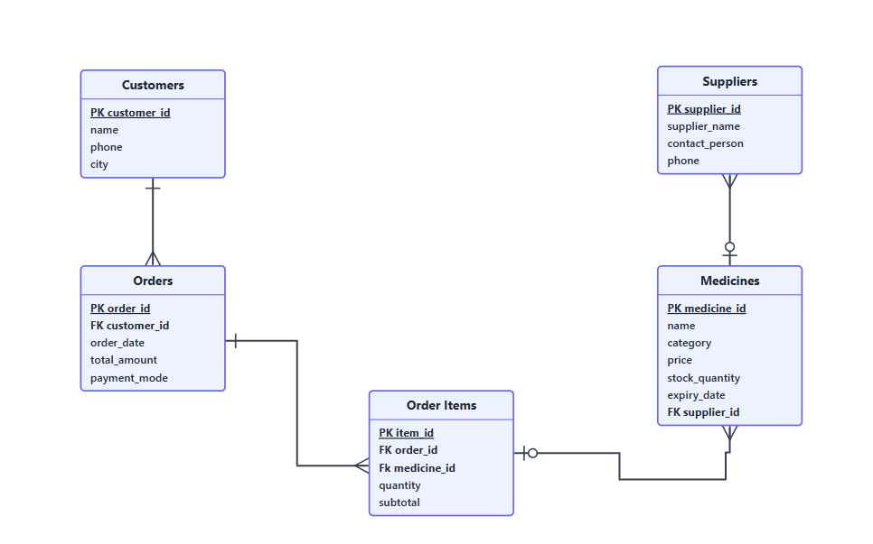

PK primary Key
FK foreign Key

Relations:
- Customers to orders: 1 to many
- Orders to order items: 1to many
- Order items to medicines: many to 1
- Medicines to suppliers: many to 1

Sample Data:
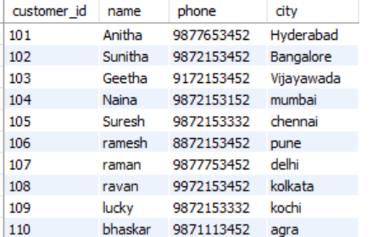
Customers:

Orders:
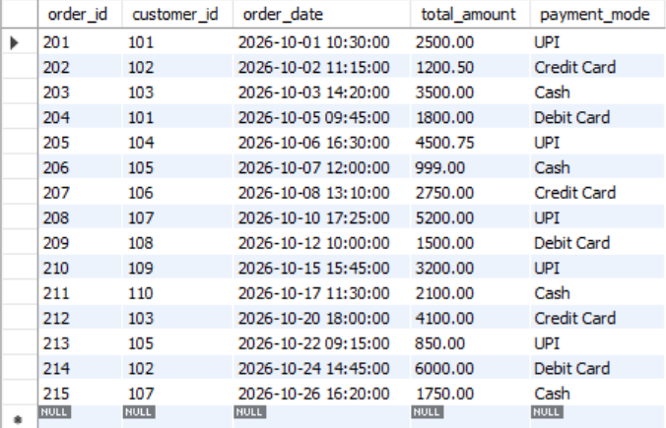

OrderItems:
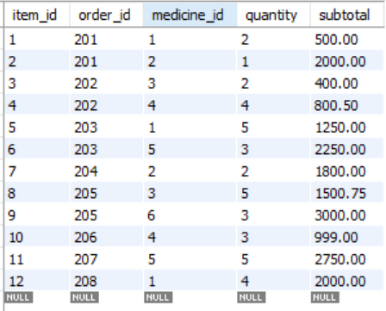
Medicines:
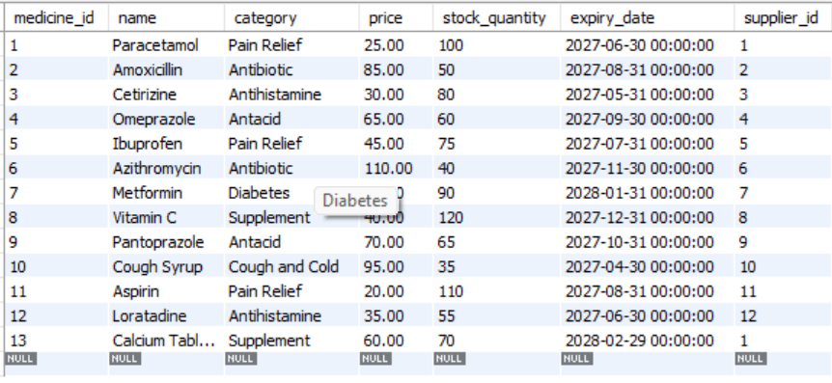
Suppliers:
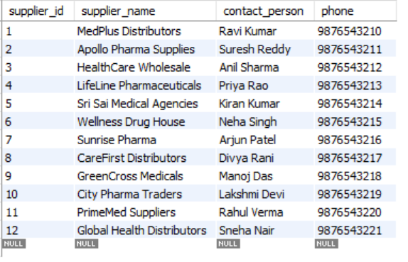

Queries:

